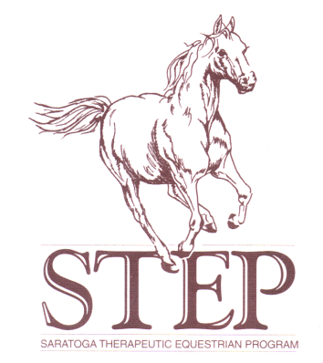
STEP UP at New Forest Equestrian Center
P.O. Box 2918
Glenville, NY. 12325-0918
Phone(barn): (518) 374-5116

Dear Physician,

The Saratoga Therapeutic Equestrian Program Inc. (STEP) offers PATH/AHA Equine Assisted Activities and Therapy designed to benefit its participants physically, socially and emotionally.

We use specifically trained horses and trained volunteers with our core staff of licensed physical therapists, occupational therapists, speech language pathologists, psychologists, social workers, special education teachers and PATH certified instructors with the necessary safety equipment, policies and procedures in order to assure the fullest possible protection and greatest personal benefit from the program. Each participant is required to furnish medical information before being accepted into our mounted and non-mounted and/or driving programs.

Please fill out the reverse of this letter and the enclosed form. If you have any questions, please do not hesitate to call.

NOTE

Because of the nature of the activity of horseback riding, no individual diagnosed with Down’s Syndrome can be accepted for riding instruction without proof of a negative diagnostic x-ray for Atlanto-Axial Dislocation Condition and must have yearly neurological follow up and clearance.

Thank you
Karen Stanley-White PT MSCS
Executive Director STEP
STEP UP at New Forest Equestrian Center
P.O. Box 2918

Glenville, NY. 12325-0918
Phone (barn): (518) 374-5116

Client’s Name: ______________________________________ Phone: _____________

Physician’s Prescription

Prescription for Therapeutic Horseback Riding.
Prescription, where appropriate, for evaluation and treatment by a Physical, Occupational, and/or Speech Therapist in conjunction with the Therapeutic Horseback Riding.

Recommended Frequency: ________________________________________________

Precautions: ____________________________________________________________

_______________________________________________________________________

_______________________________________________________________________

Physician’s Signature: ____________________________________ Date: ___________

(Please print, type or stamp)
Physician’s Name: _______________________________________________________

Address: _______________________________________________________

Phone: _______________________________________________________

Medical Release

This client has my permission to participate in a horseback riding program under appropriate supervision.

Recommended Frequency: ________________________________________________

Precautions: ____________________________________________________________

_______________________________________________________________________

_______________________________________________________________________

Physician’s Signature: ____________________________________ Date: ___________

Physician’s Name: _______________________________________________________
(Please type print or stamp)
Address: ______________________________________________________

Phone: _______________________________________________________

